MiAccess – Multilingual Information for People with Disability and their Carers
Stakeholder Kit
April 2021
Table of Contents
National Culturally and Linguistically Diverse (CALD) Information Program (Introduction) 3
Multilingual Information Access - MiAccess Introduction 3
Spread the Word 4
MiAccess Branding 5
Brand Colours 6
Key Messages 7
Social Media 7
Social Media Graphics or images 10
Graphic 1 10
Graphic 2 10
Graphic 3 10
Graphic 4 10
Graphic 5 11
Graphic 6 – images 11
Q & As 12

National Culturally and Linguistically Diverse (CALD) Information Program
Cultural Perspectives have been delivering the National Culturally and Linguistically Diverse (CALD) Information Program under the Information Linkages and Capacity Building (ILC) Grant by the Department of Social Services (DSS).
The National CALD Information Program addresses the lack of access to information about disability and the NDIS within CALD communities. The activity being delivered includes:
- The creation of a website that brings together existing translated information about the NDIS and conditions funded under the NDIS as a ‘collection/hub’;
- Extension of the availability of in-language information into new languages (particularly where translated information has not yet existed);
- The creation of immersive virtual reality (VR) learning experiences as a way of communicating personal stories of people with disability from CALD communities and the way in which an NDIS plan has empowered them and increased their quality of life; and
- Promotion of the Information Program and its activities through a comprehensive distribution and engagement plan for activities in 2021-2022. This includes information distribution, marketing, attendance at disability sector conferences to promote cultural responsiveness and dissemination of the VR experience via partnerships with CALD sector organisations.

MiAccess - Multilingual Information Access
MiAccess (www.miaccess.com.au) is a new website that hosts translated information and resources on disability and the NDIS in over 30 languages.
The purpose of the website is to address challenges in CALD communities of access to information about disability and the NDIS in-language, and to improve understanding within CALD communities about the NDIS and its supports.
About MiAccess:
- MiAccess can be navigated in the following 10 languages: Arabic, Cantonese, Dari, Korean, Mandarin, Persian (excluding Dari), Punjabi, Spanish, Thai, and Vietnamese
- Accessible on computer/desktop and mobile devices
- MiAccess hosts resources on NDIS disability areas and general information regarding the NDIS that can be accessed in over 30 languages
- Access to experienced cross-cultural trainers and organisations in the area of CALD disability have also been listed on the website and can be accessed at the following link: http://www.miaccess.com/find-a-trainer/
- Providing greater understanding on disability issues in CALD communities. Access to relevant publications and resources at the following link: http://www.miaccess.com.au/disability-in-cald-communities/

Spread the Word
We appreciate any assistance you can provide in distributing information about MiAccess within your networks. Greater promotion and awareness of MiAccess will allow for greater access to information for people with disability, their carers, and CALD communities.
In this kit you will find key messages and tools that will assist in communicating about MiAccess.
We encourage you to use the messages and tools within this document to ultimately provide greater access and information about the NDIS and disability areas for people with disability, their carers and CALD communities.

MiAccess Branding
The following logo has been developed for use in the promotion of MiAccess.
Below you will find four (4) versions of the logo that can be purposed for your intended audience and communication platform.
We request that you do not make any modifications to elements of the logo outlined below. This includes no cropping of the image, additional effects, or changes to colour.
MiAccess – Primary
The MiAccess primary logo consists of typography, line, and block of colour.
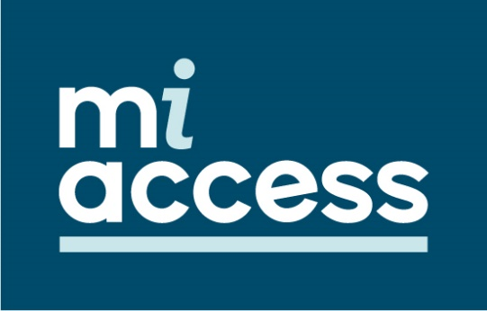
MiAccess – Secondary
The MiAccess secondary logo consists of typography, line, and block of colour.
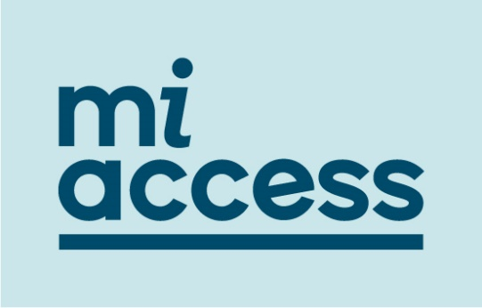
MiAccess – Transparent
The MiAccess logo has two options with a transparent background, for use when needed.
These variants consist of typography and line.
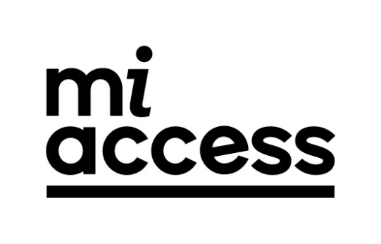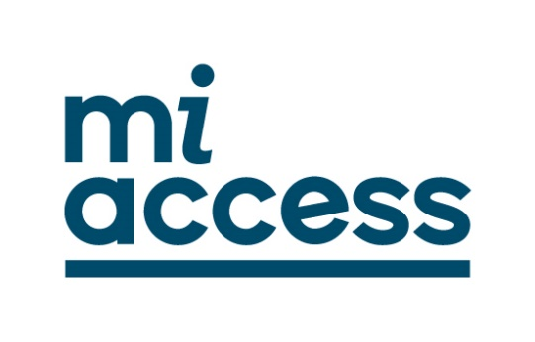

Brand Colours
When promoting MiAccess and using the logo, it is recommended when possible to use the colour variety options below.
The MiAccess colour palette consists of two primary colours, navy, and light blue. Secondary colours are available and complement the primary colours.
R=0  G=74  B=106 | R=202  G=230  B= 234 | R=53  G=109  B=186 | R=80  G=153  B=186 | R=255  G=182  B=25 | R=0  G=0  B=0

Key Messages
- MiAccess (Multilingual Information Access) is a purpose-built website for people with disability, carers, and communities from CALD backgrounds.
- MiAccess can be found at www.miaccess.com.au and navigated in 10 languages, other than English. These languages include Arabic, Cantonese (Chinese Traditional), Dari, Korean, Mandarin (Chinese Simplified), Persian (excluding Dari), Punjabi, Spanish, Thai, and Vietnamese.
- MiAccess contains translated resources in over 30 languages related to disability and the NDIS. Resources can be accessed in different formats such as fact sheets, videos, audio and more.
- MiAccess connects reliable cross-cultural training organisations and options to those working in the sector to ensure people from CALD communities are understood and considered in service delivery.

Social Media
Social media tiles and messages have been created to help you spread information about MiAccess.
Key Message | Image
MiAccess is now available.  Access translated resources on disability areas and the NDIS in over 30 languages at www.miaccess.com.au | 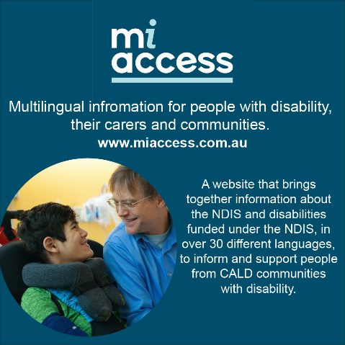
MiAccess can now be accessed and navigated in 10 languages, as well as English. Head over to  www.miaccess.com.au to find out more. | 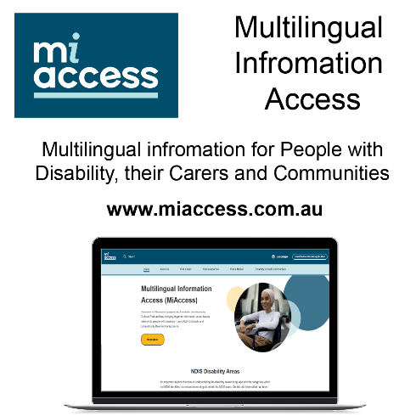
Looking for information in your language about disability or the NDIS?
MiAccess has resources available in over 30 languages that can be easily accessed at www.miaccess.com.au
Do you provide services to people from culturally and linguistically diverse backgrounds? Discover experienced cross-cultural trainers and organisations providing a range of training and services on MiAccess
www.miaccess.com.au/find-a-trainer/
Are you caring for someone with a disability? Access translated resources on NDIS disability areas in over 30 languages at www.miaccess.com.au | 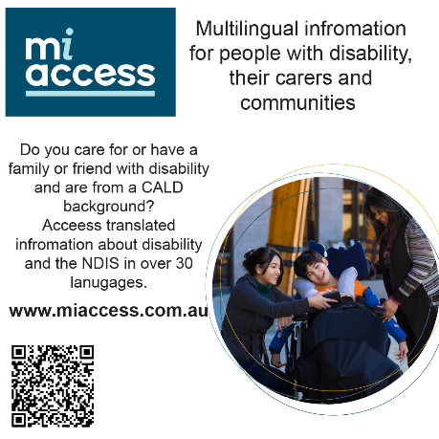
MiAccess, is a purpose-built site for people from CALD backgrounds. The site contains translated resources about disability and accessing the NDIS.  Visit www.miaccess.com.au to view information now. | 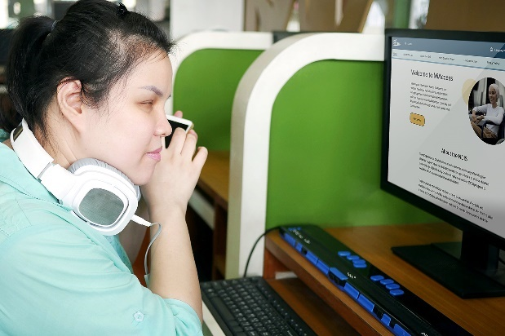
Want to learn more about the NDIS and how it can be accessed?  Find resources on the NDIS and how it can be accessed over on www.miaccess.com.au | 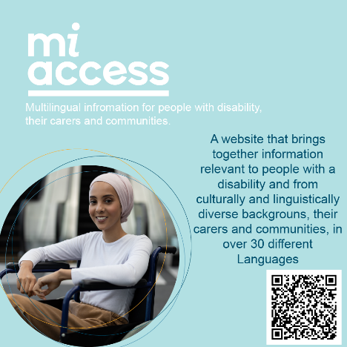
MiAccess has been developed for people with disability from CALD backgrounds, their carers, and communities.  If you or someone you know are looking for information or resources in a language other than English, please visit www.miaccess.com.au | 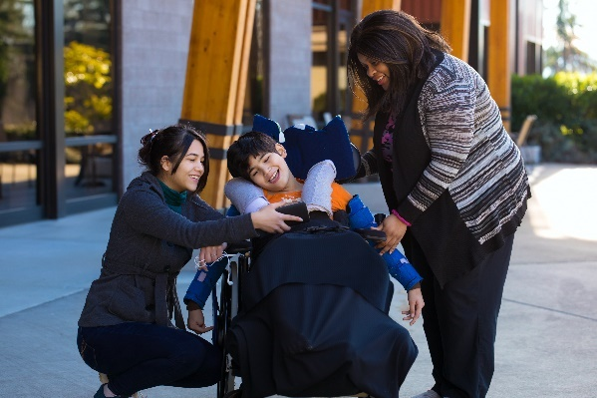
Would you like to access information on disability and the NDIS in a language other than English?  Visit www.miaccess.com.au to find a resource in your preferred language. | 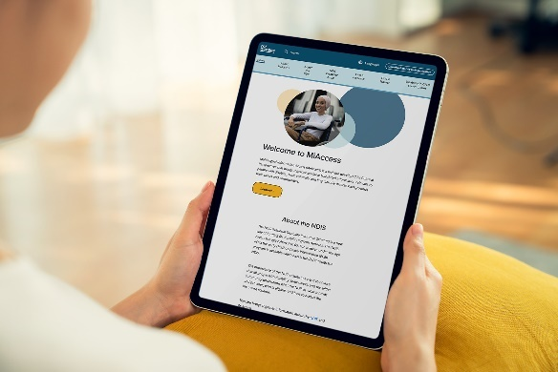

Social Media Graphics/Images

Graphic 1
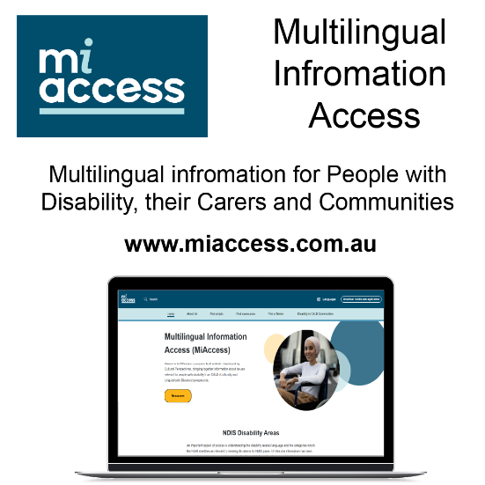

Graphic 2

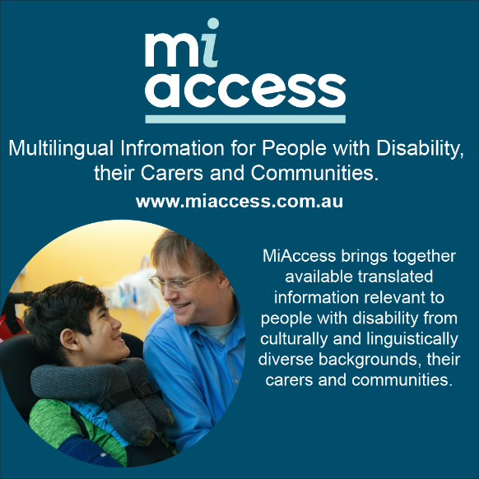

Graphic 4
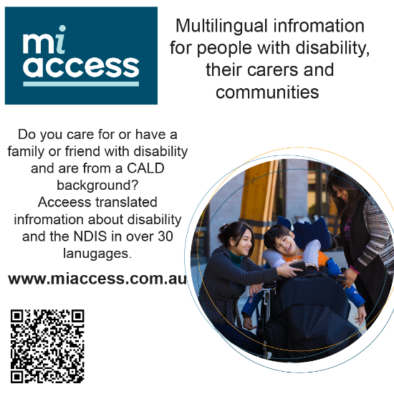

Graphic 5
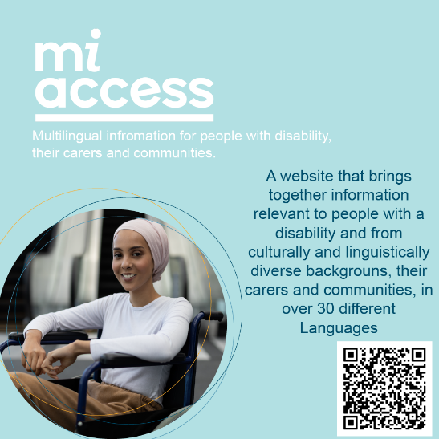

Graphic 6 – images
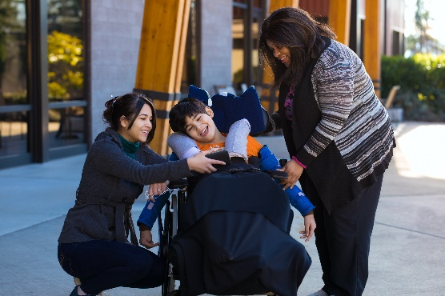

Q & As

Q: What is MiAccess?
A. MiAccess, short for ‘Multilingual Information Access’ is a purpose-built website to increase the amount of information about disability, CALD communities and the NDIS in an accessible and language supported platform.
Q: Who is MiAccess for?
A: MiAccess has been developed to increase the availability of translated information for people with disability from CALD backgrounds, their carers, and a range of intermediaries who interact with them. As such the site will have multiple audiences but its main focus is on providing high quality and well translated materials for people with disability themselves.
Q: Who manages MiAccess?
A: MiAccess has been developed by Cultural Perspectives with funding under the ILC (Information, Linkages and Capacity Building) Program of the NDIS which is currently managed by the Department of Social Services. Cultural Perspectives also has the role of ensuring that information is kept current and relevant to the needs of people disability from CALD backgrounds and their carers.
Q: How do I register translated information that I think is relevant to MiAccess?
A: Cultural Perspectives is interested in identifying high quality translated information that is suitable to both the structure and intent of the MiAccess, which is to increase access. If you want to discuss your resources with us, please use the contact form to advise us of the resources or email info@miaccess.com.au with the details.

If you have any questions or would like further information please contact MiAccess at info@miaccess.com.au or visit www.miaccess.com.au/faqs/.

